Rules and Laws
You are most welcome to review the professional Laws of Carrom adopted by the International Carrom Federation, though I personally would not recommend that for beginners or casual players.
Most visitors would find the following simplified carrom rules quite useful to get started with the game.
Generally speaking, two or four people can play carrom. If two, the players sit opposite each other, while with four, the opposite two are partners. As an exception, though, you can play with three players against each other for points.

Arrange the carrom men on the centre circle of the carrom board as shown in the following illustration, with the red 'queen' at the centre. The whites should be lined up to form a "Y" shape, with two sides aiming directly towards the corner pockets.
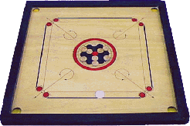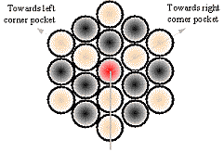
Each player sits on his side of the board and can only strike from that side. The contestant playing white 'breaks' or plays first, which can be decided by the toss of a coin. The object of the game of carrom is to sink all of your carrommen, using the heavier 'striker', in any of the pockets before your opponent. Your turn continues as long as you keep sinking your carrom men - luck shots count and all combinations are permitted.
When placing the striker on the board to shoot, it must touch both 'base lines', either covering the end circle completely, or not touching it at all. The striker may not touch the diagonal arrow line.

Correct Striker Placement

Incorrect Striker Placement
Shooting styles are very personal - whichever 'grip' works for you is fine as long as you 'flick' the striker and don't push it. Generally, it's best to orient your body in order to see the line of your aim while shooting comfortably; you may not move or leave your chair.
For forward shots, you can use your index finger, middle finger, or even the 'scissors' shot. Before shooting, try touching the striker with your fingernail, to be sure that its really on line. This will improve your accuracy and prevent you from hurting your finger.
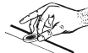 | 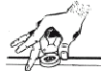 | 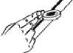
Index Finger | Middle Finger | 'Scissors' Shot

For 'back-shots' you may only use your thumb or the scissors technique.
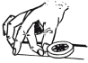
No part of your body, except your hand, may cross the imaginary diagonal line nor may your elbow protrude over the frame in front of you. Even your feet or knees my not leave your quadrant.
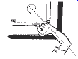
Incorrect Arm Position

The red 'queen,' can be pocketed at any time after sinking your first piece but must be sunk before your last one. After pocketing the queen, you must sink one of your carrommen, thereby 'covering' it, into any pocket in the next shot, or she is returned to the center spot.
Once the queen is covered, whoever clears all their carrom men first wins the 'board'.
The winner of a board collects one point for each of the opponent's carrom men left at the finish and three points for the queen if covered by the winner (if covered by the loser, no-one gets those points). No more points are collected for the queen after your score reaches 22.
A game consists of 25 points or eight boards, whichever comes first.

- Sinking the striker costs you one piece and your turn. But, if you sink a piece in the same shot, then two come up and you shoot again.
- After sinking the striker, your opponent places the due piece(s) within the center circle. If you haven't sunk one yet, you owe one.
- If while shooting for the quee,n you also sink one of your carrom men in the same shot, the queen is automatically covered, no matter which went first.
- If a piece jumps off the board, it is placed on the center spot. If pieces land on end or are overlapping, they are left that way.
- If the center spot is partially covered when replacing the queen or a jumped piece, the piece should cover as much red as possible. If totally covered, the piece is placed opposite the next player behind the red spot.
- If you sink your opponent's piece, you lose your turn. If you sink their last piece, you lose the board and three points.
- If you sink your last piece before the queen, you lose the board, three points and one point for each of your opponent's pieces left.
- If the striker does not leave both lines, go again. You get three tries to break before losing your turn.
Special thanks to Carrom Board Centre for providing some illustrations used on this page.

